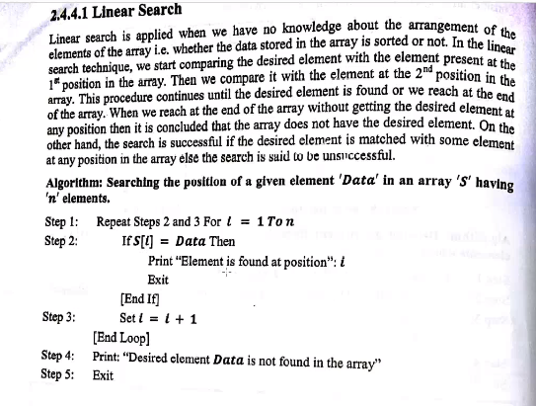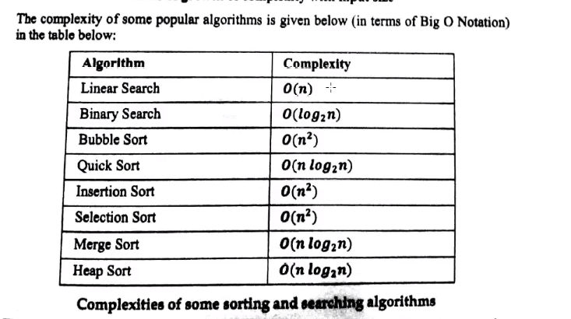

**Linear search**

🡺#include <iostream>

using namespace std;

int main()

{

int a[10]={1,5,7,89,24};

int ele=7,f;

f=1; //Element not found

for(int i=0;i<5;i++)

{

if(a[i]==ele)

{

cout<<"Element found at "<<i<<endl;

f=0;

break;

}

}

if(f==1)

cout<<"Element not found";

return 0;

}

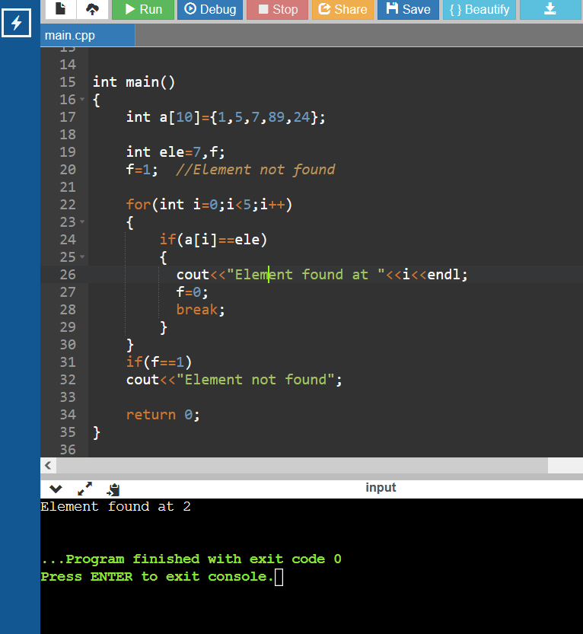

2) Binary search

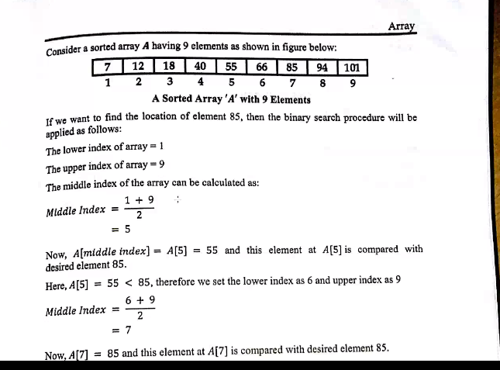

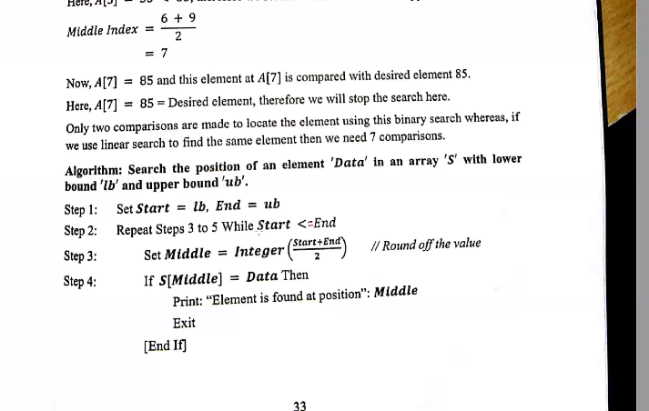

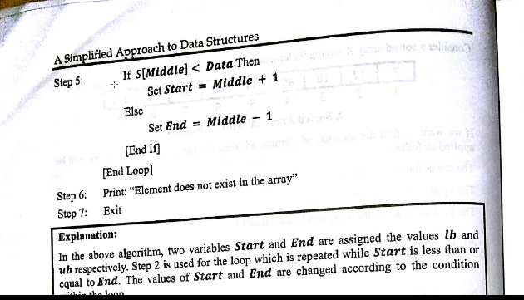

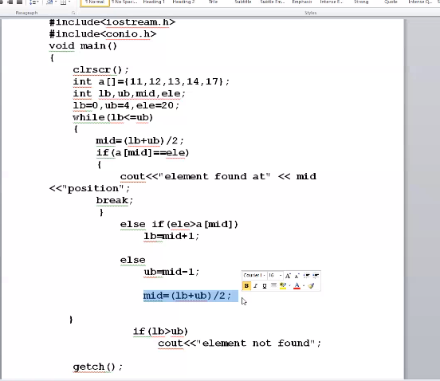

🡺#include <iostream>

using namespace std;

int main()

{

int a[]={5,8,34,66,33,77};

int lb,ub,mid,ele;

lb=0;ub=4,ele=34;

while(lb<=ub)

{

mid=(lb+ub)/2;

if(a[mid]==ele)

{

cout<<"Element found at index "<<mid<<endl;

break;

}

else if(ele>a[mid])

lb=mid+1;

else

ub=mid-1;

}

if(lb>ub)

cout<<"Element not found"<<endl;

return 0;

}